1. Properties> Use street view as property picture. Come down to the listings menu. See if the change is reflected.
2. Applying from the tenant side through the “lens” icon at the top. There is a rental application fee set by the landlord too.

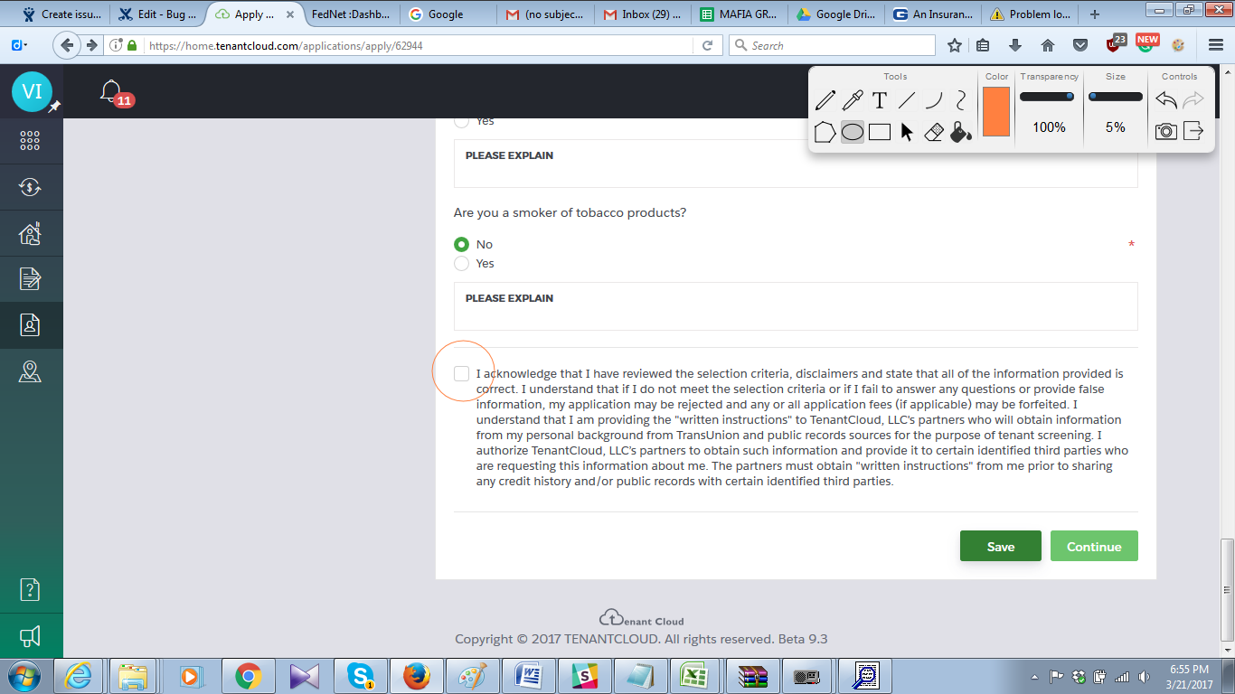

Even after checking the “I acknowledge”, clicking save button brings up another page where “I acknowledge” is unchecked.

4.

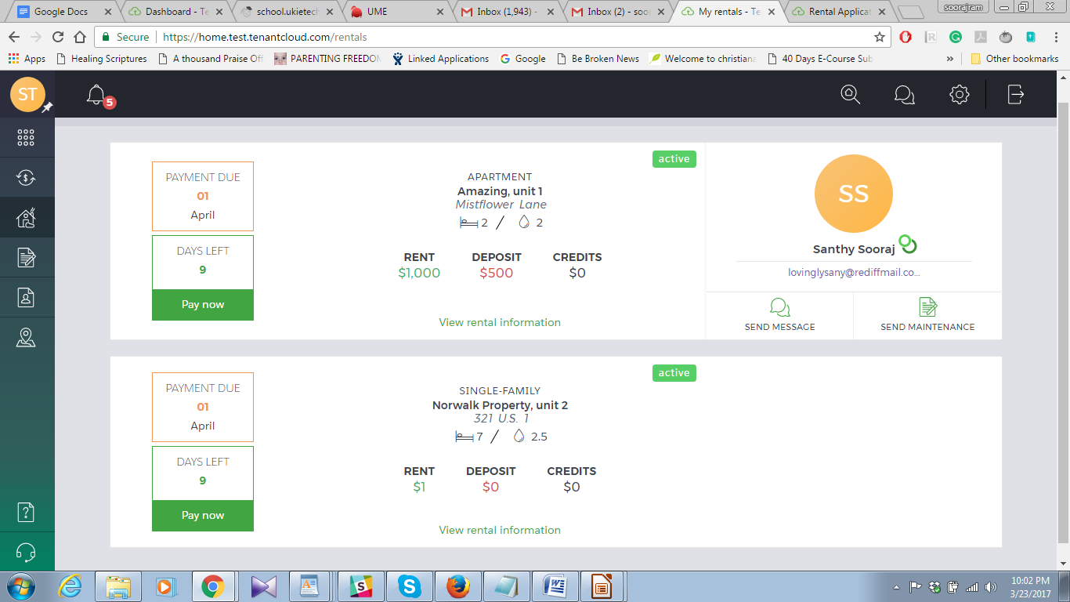

Created a tenant from the landlord side. Deleted the tenant but still it shows as active (the one at the bottom).

5. 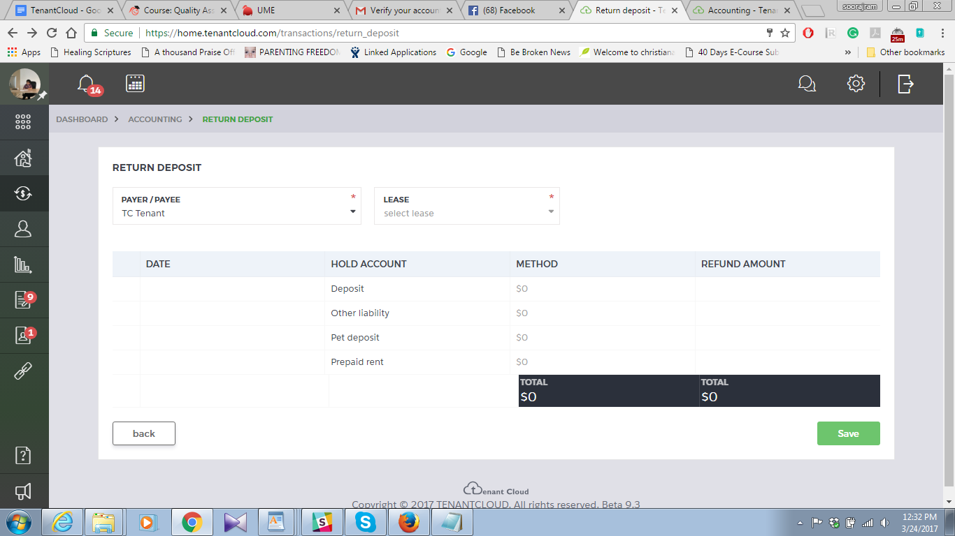

Return deposit showing 0 for all. Confirm.

6.

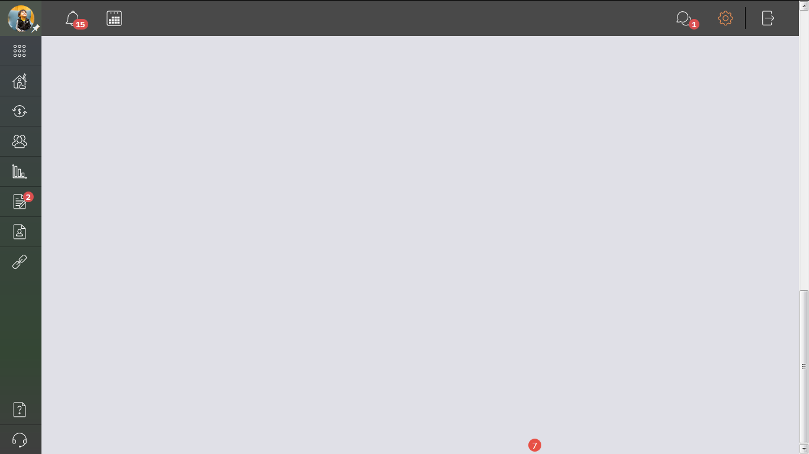

Bottom of rental agreement a “7” is there.

7.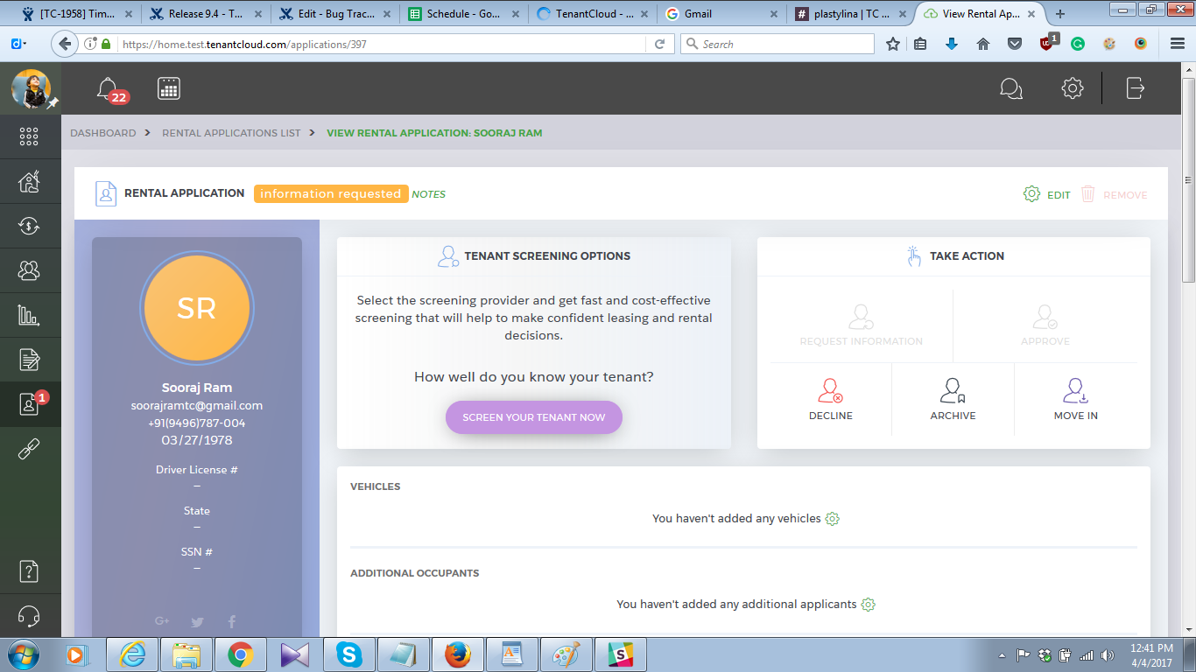

Request information does not look like working.

8. 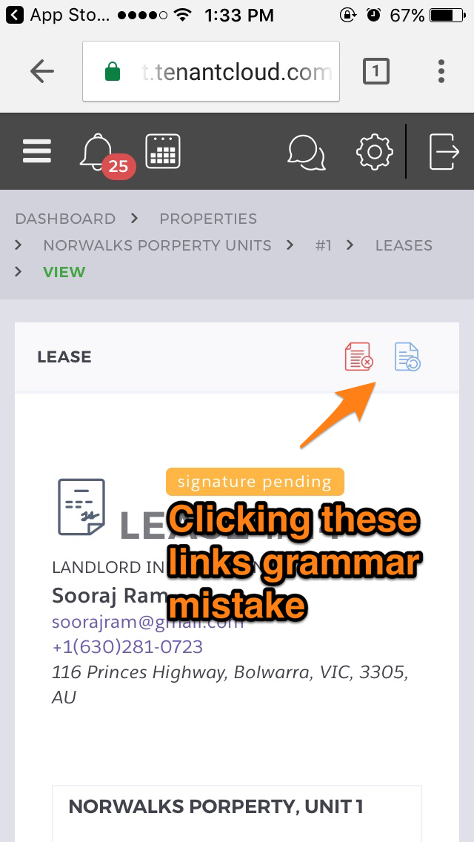

9. 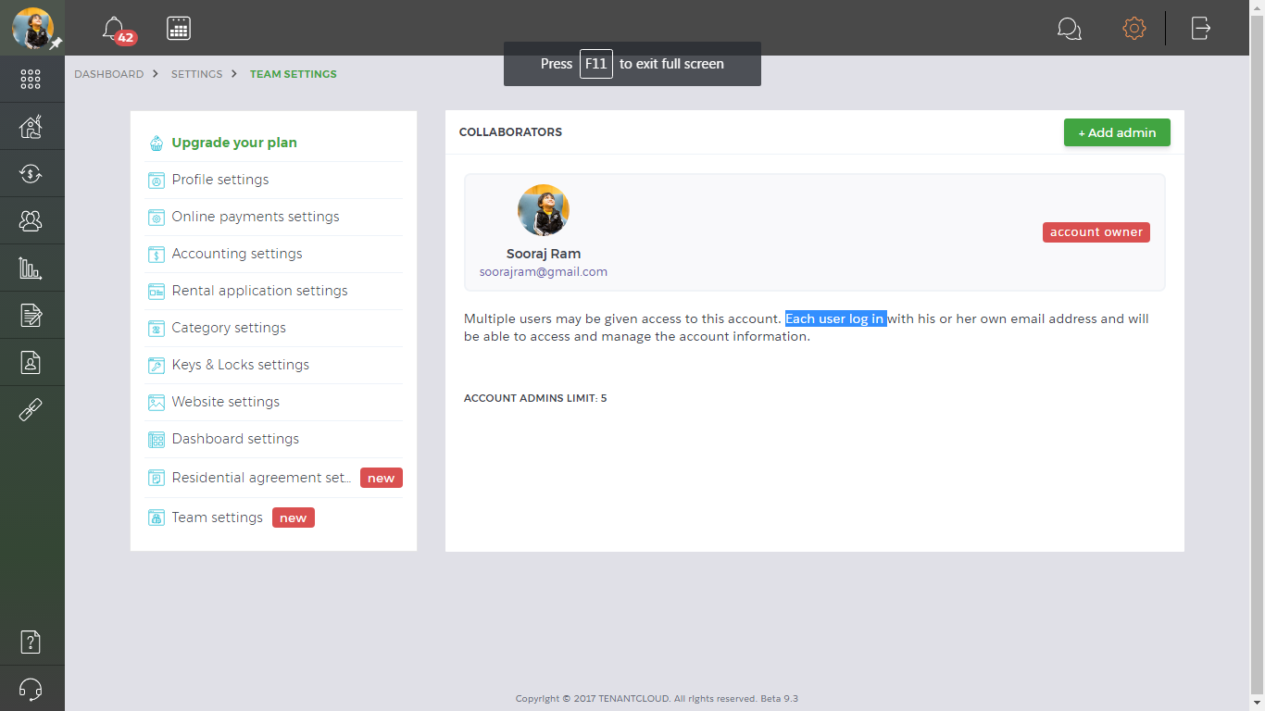

Grammar.

10.

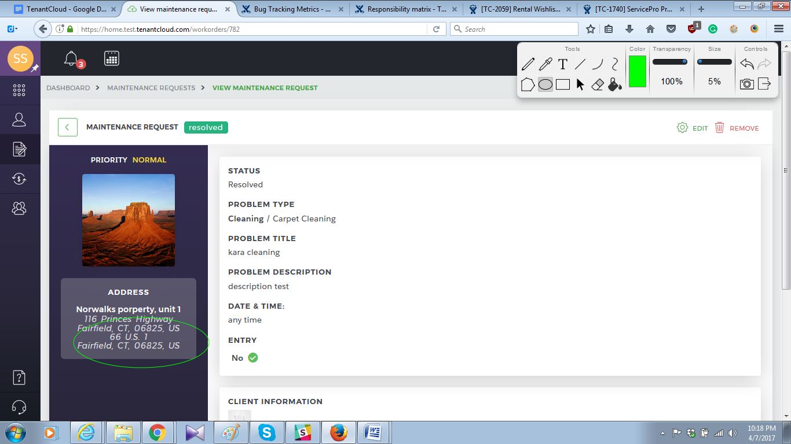

11. 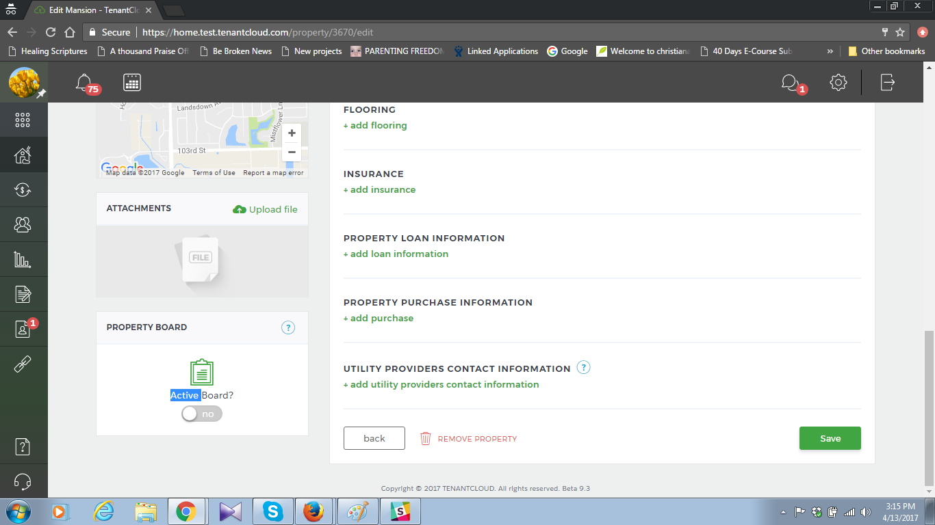

Activate?

12. 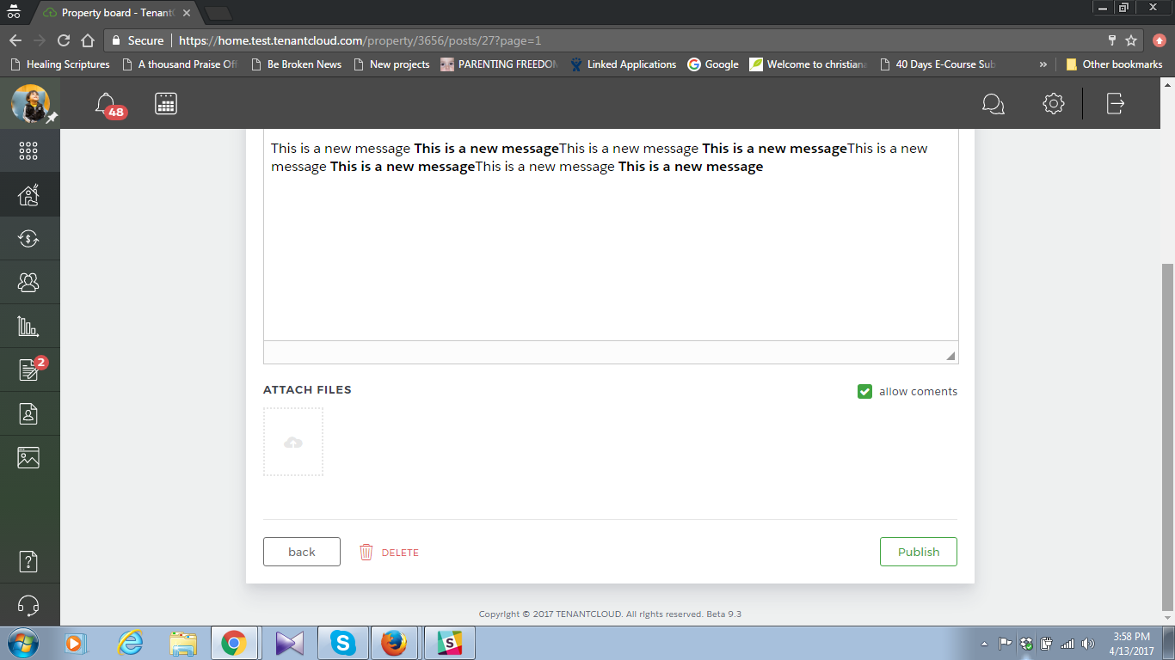

Property board>Edit “Allow comment” typo

Suggestions:

1. In the home page below “Welcome to TenantCloud”   
   Your personal cloud office for all your rental information. In this news feed you'll get real-time notifications so you don't miss important messages.   
   To start using TenantCloud:  
   -fill in your renter profile. (Couldn’t this be a link to the “renter profile” page? The same place in Landlord website, there is a link for every item)  
   +-add your rental information-connect your landlord to your rental

Landlord login

<https://home.test.tenantcloud.com/reports>

Do you need

[1. Financial report](https://home.test.tenantcloud.com/reports/view/monthly_property_report) **[Monthly Property Report](https://home.test.tenantcloud.com/reports/view/monthly_property_report)**

This report shows the property accounting based on each unit. The income and expenses including payment to owner and management fees.

4. Convenience: Information is accessible any place anywhere. If you can connect to the internet then you can define your workplace. Including multiple devices. (<https://www.tenantcloud.com/blog/moving-to-cloud-can-save-you-time-and-money>)

5. Security: Your personal computer, a drawer or notebook are all subject to such events as floods, fire or even theft. Your laptop or phone might contain valuable information like pictures or messages from tenants and if it is damaged then it's gone forever. Keeping your data in such places exposes you to many risks. Storing your information on the cloud saves your information from data loss and theft. Tenants information is important,

6. <https://www.tenantcloud.com/faq/question/12>   
Tenant account allows users to fill in their personal rental data (and?) store necessary documents.

7. <https://www.tenantcloud.com/faq/question/56> In the **Late Fee Settings** block, select One to rent late fee (One time?), Daily late fee, or both, and the system will automatically generate

8. **Inviting landlord for a connection. Landlord didn’t get an email. This was before a connection was established.**

9. <https://home.tenantcloud.com/transactions/add_invoice?transaction_type=4> There was a tenant who is connected by a lease and one who isn’t. While choosing payer name from add expense, both are shown, whereas, the one with no connection doesn't have a role here.

10. <https://home.tenantcloud.com/reports>   
 A. The income and expenses including(include) payment to owner and management fees.

16. <https://www.tenantcloud.com/blog/how-to-be-a-great-landlord>

(check them out on Rewiews.com, they rate TenantCloud as the best software for small landlords)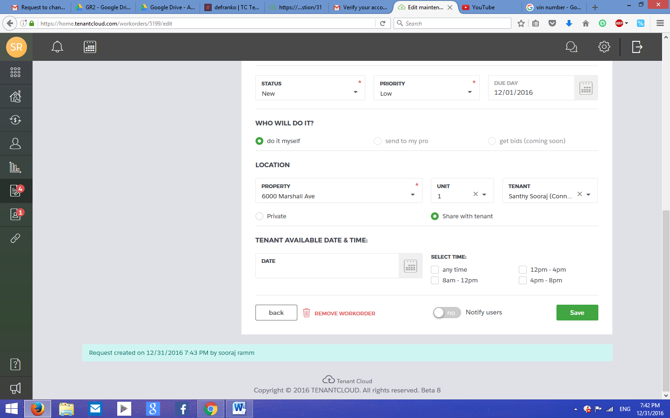

20.  
Changing profile picture. It shows all kinds of files. Should’ve showed only png and jpg files..

23. Dashboard - Todo list - set alert - click on the year. A strange looking icon appears.

24.  
moneyout/add expense /new contact - fill all fields, select tenant, push add button. Message appears “New vendor created” instead of new tenant created. (New release: you will have to put a new tenant to check this. A new professional won’t work)

27.  
The message icon at the top right shows a new message even when there is no new message.--------Confirm-------

29.

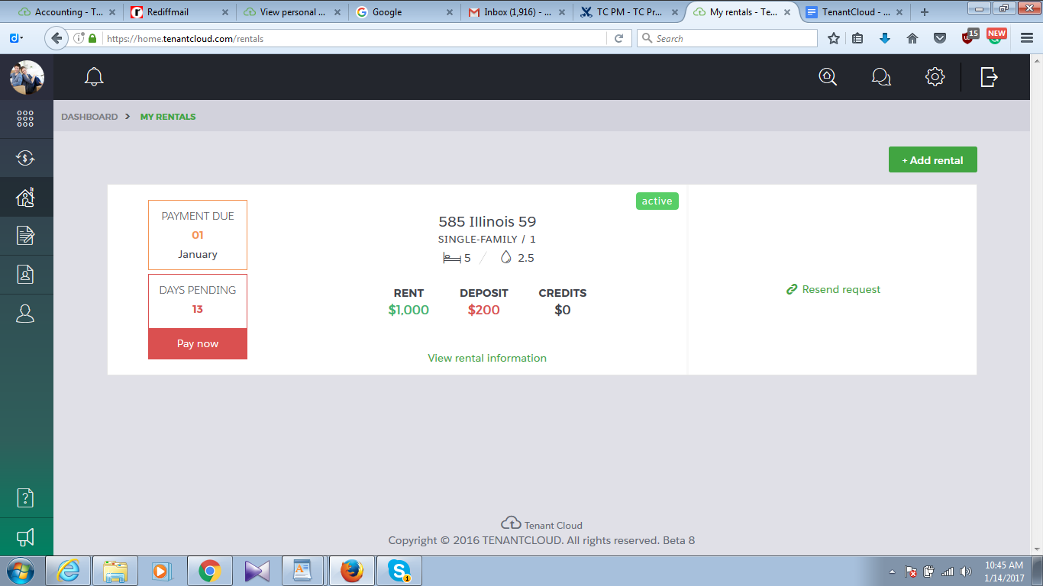  
<https://home.tenantcloud.com/rentals>   
Click on “View rental information”

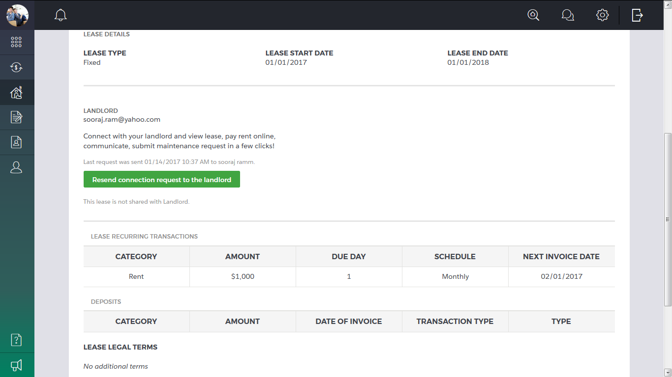  
Deposits table is empty. Neither deposits or pet deposits are shown.

30.  
<https://home.tenantcloud.com/users/tenants/54079/edit>   
Deposit field is not editable but “pet deposit” field is.

31.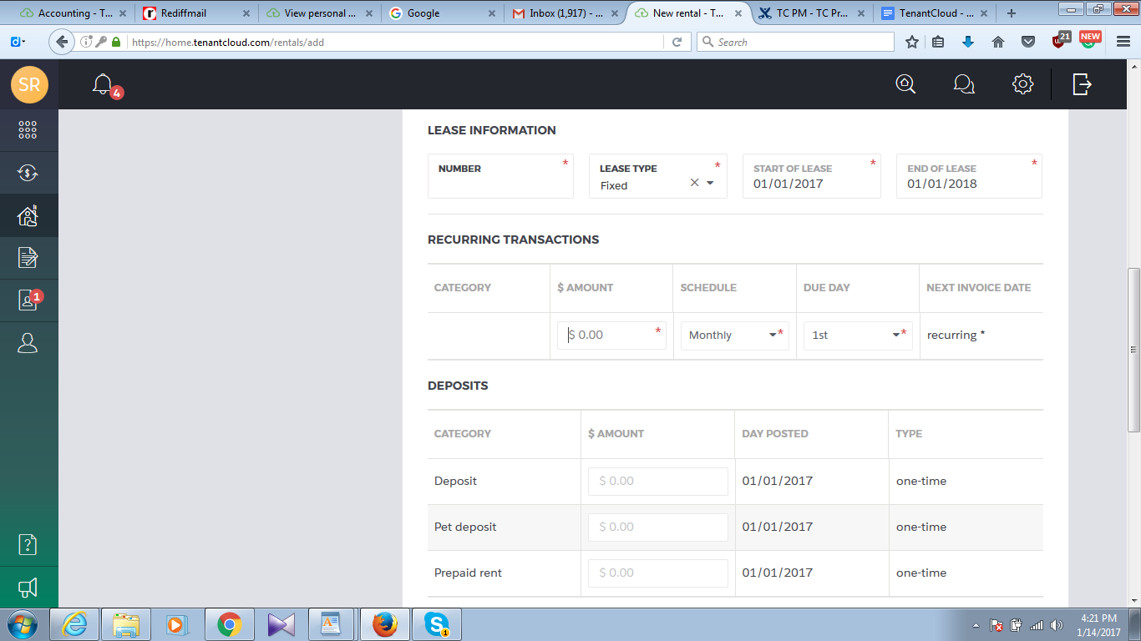  
<https://home.tenantcloud.com/rentals/add> Creating a new rental from tenant account doesn’t have prorated rent field. Compare to the picture below.

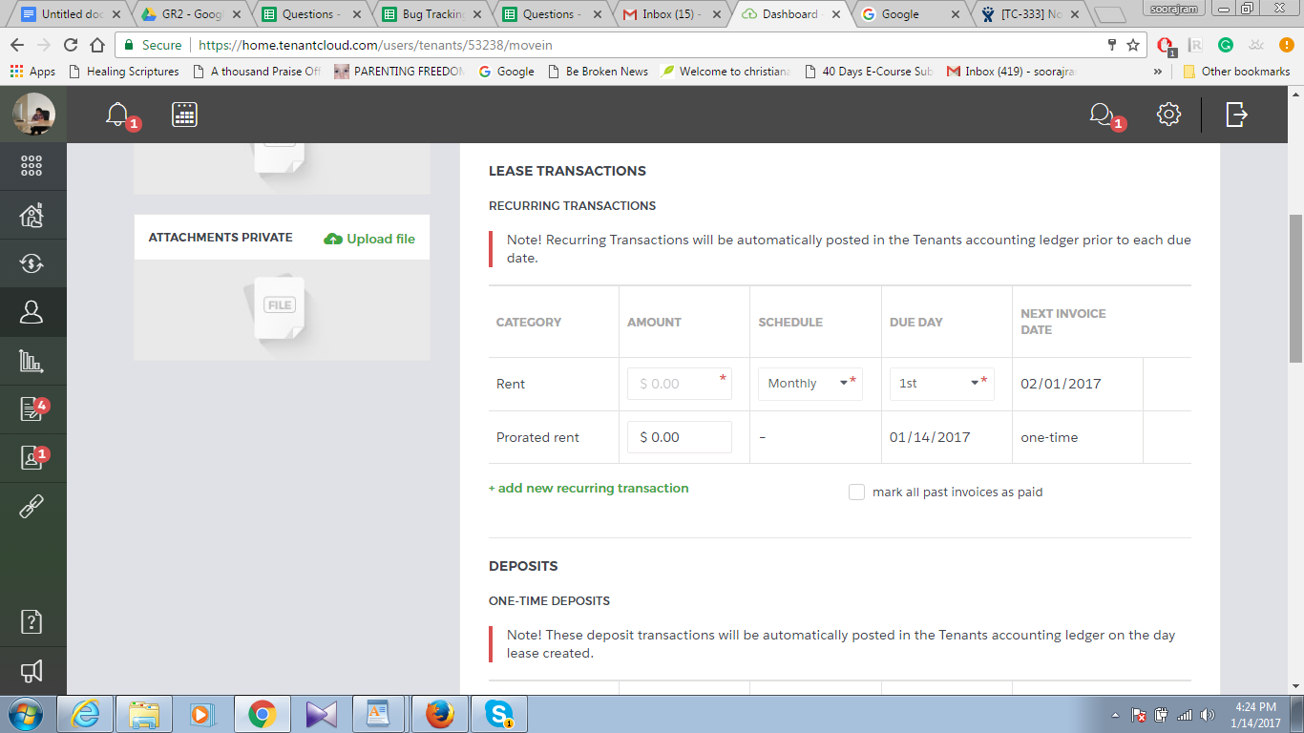  
<https://home.tenantcloud.com/users/tenants/53238/movein> Move in a tenant from landlord. The prorated rent field is present here.

32. 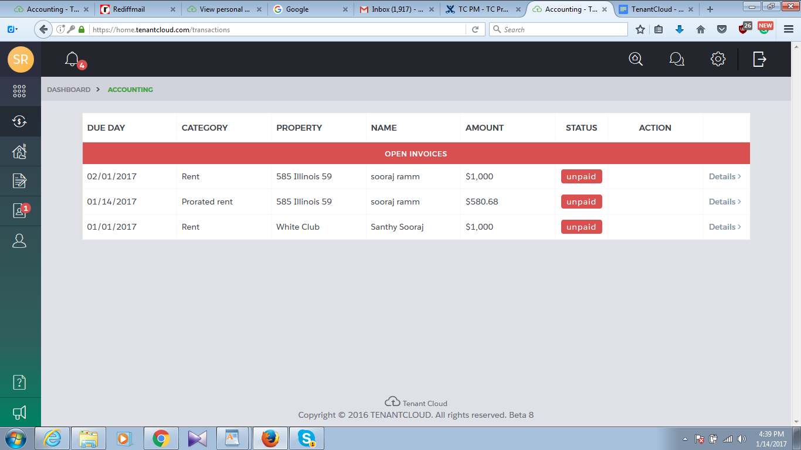  
???Shouldn’t this be “due date”????

34.

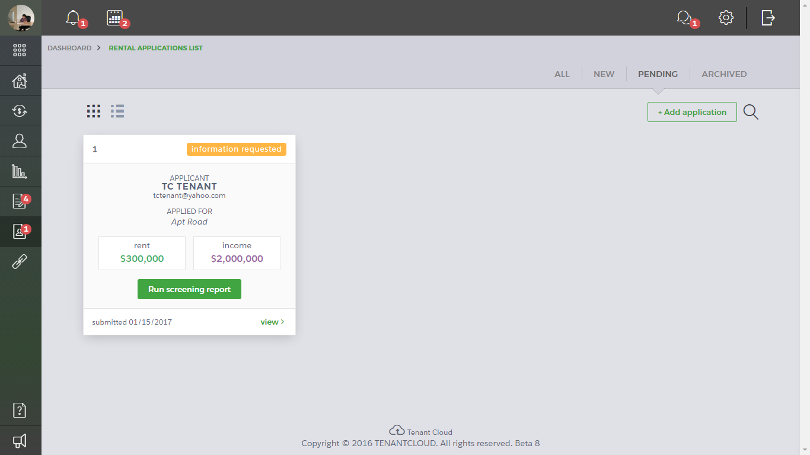  
<https://home.tenantcloud.com/applications?status=21> After “Request information”, a rental application is moved to “Pending” section. See below..

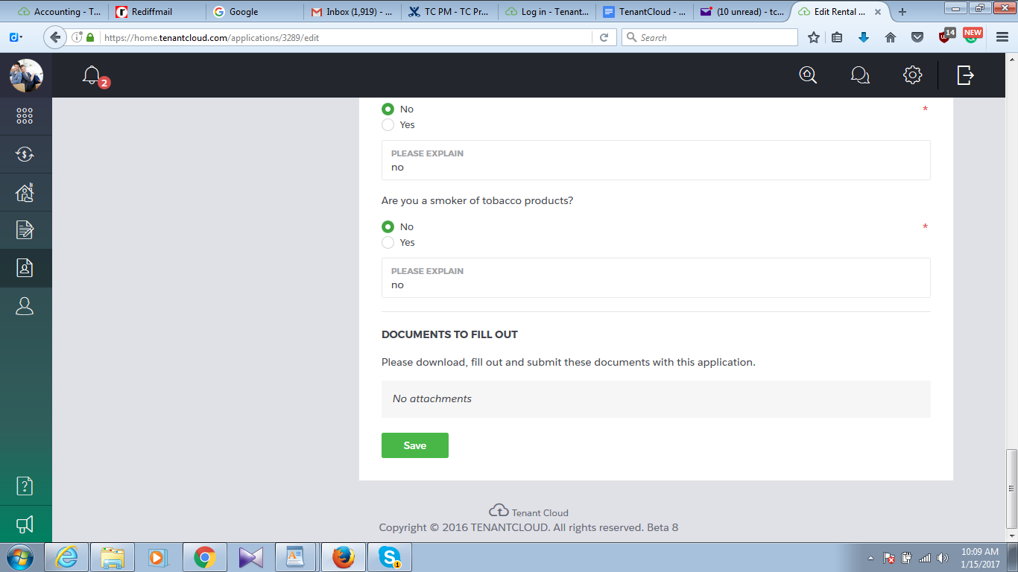  
<https://home.tenantcloud.com/applications/3289/edit> The tenant makes no change but just presses the save in “Edit rental application”  
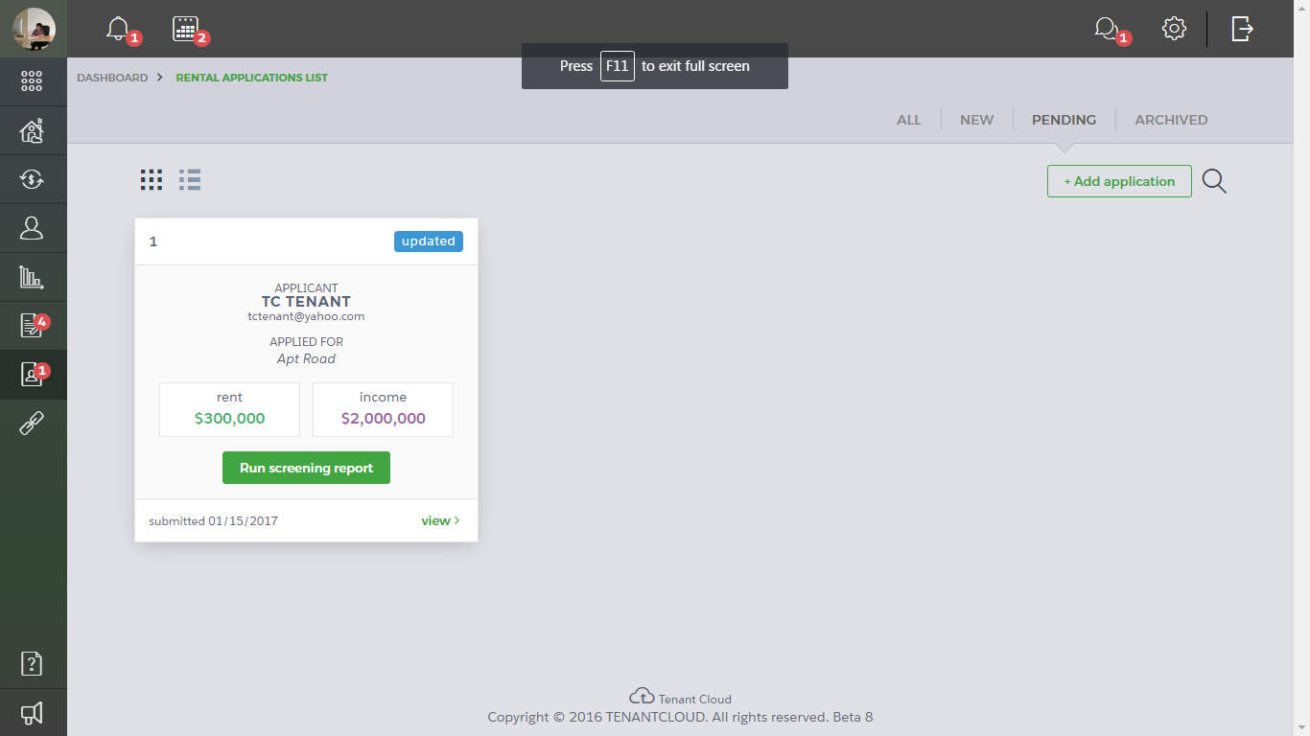  
1. Rental application is shown as updated in landlord’s side.

2. The application is still under the “pending” section even after updated.

35. 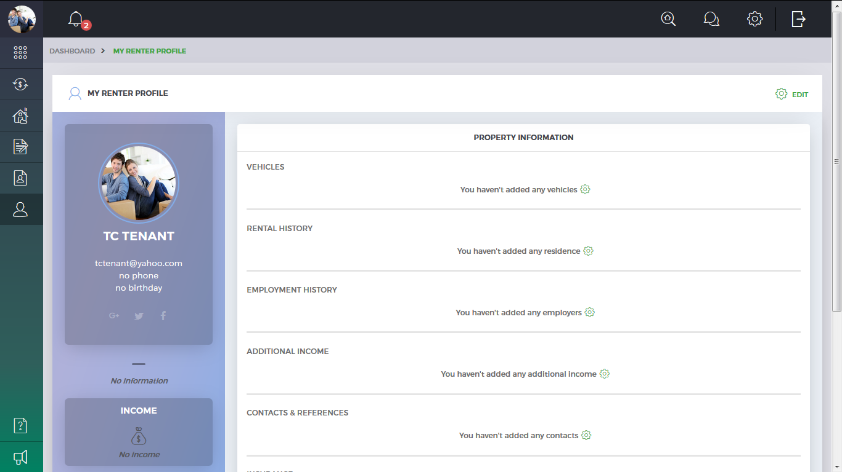  
<https://home.tenantcloud.com/profile> The heading is given as “property information”. Shouldn’t it be “tenant information” instead?

37.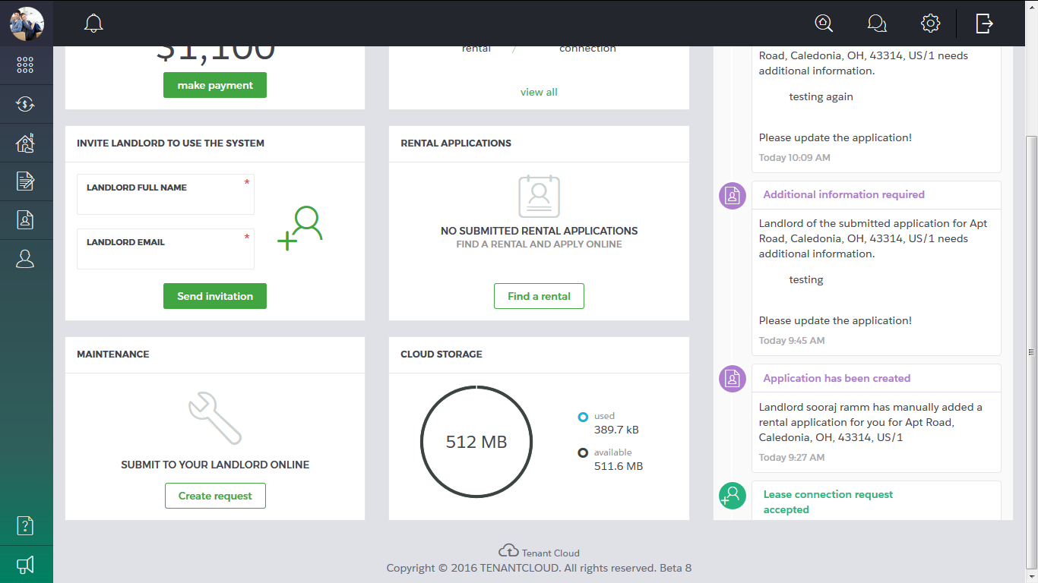  
????Submit to your landlord online frame?????

------------------------------------------------------------------------------------------------------------------------

1.

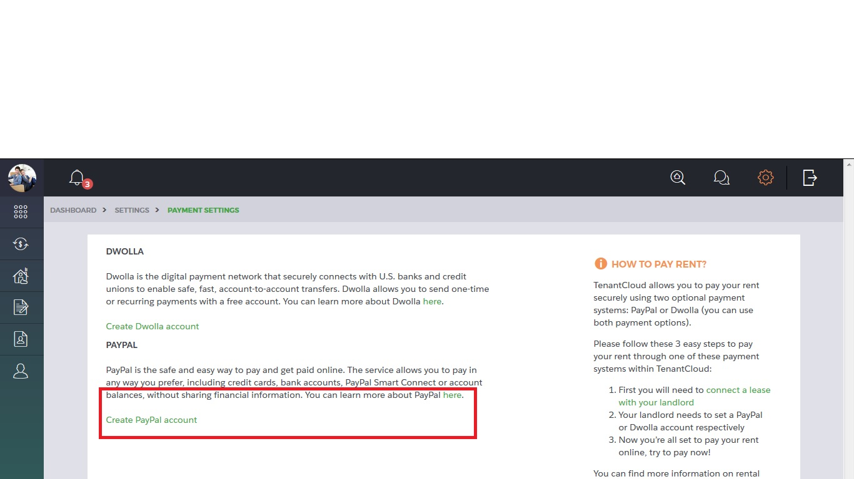  
Both links redirects to Ukraine specific paypal pages. ------clarify-----

2. 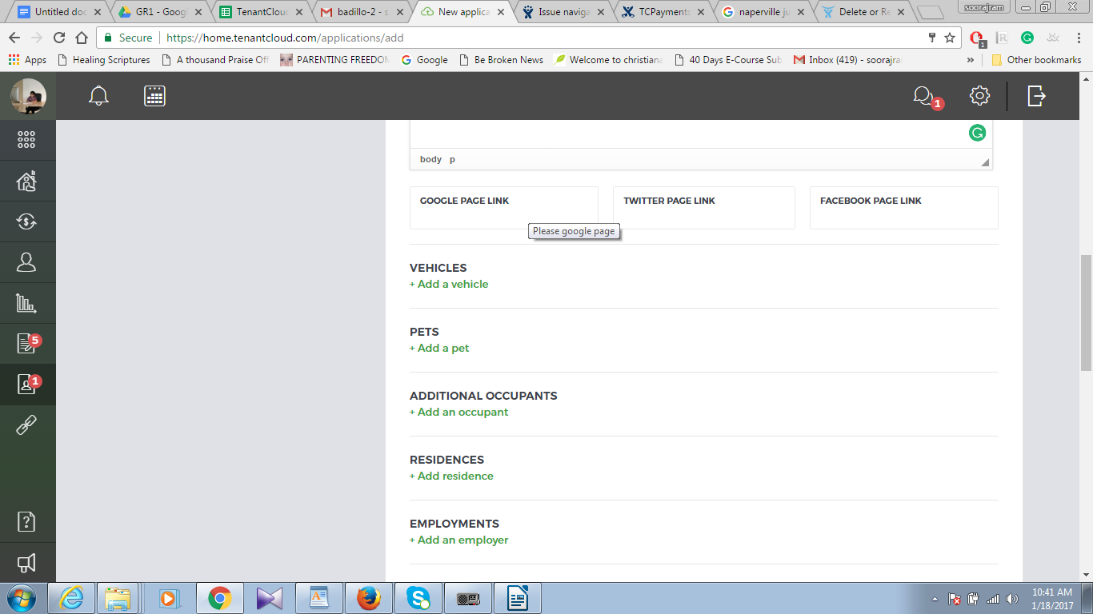

The tooltip

3. **New Release**

4. 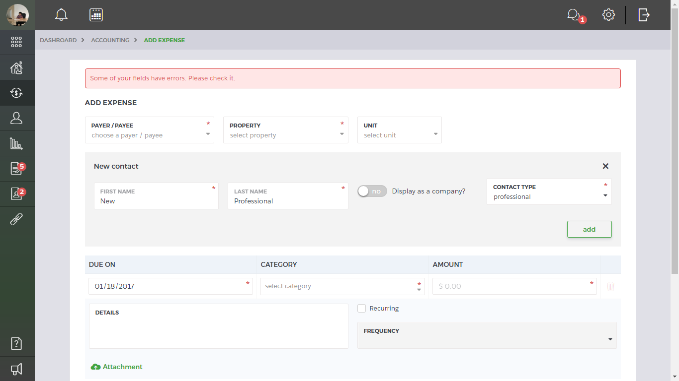  
Add expense: Payer/payee - create new contact. Choose a professional. An error comes as above comes.

5. 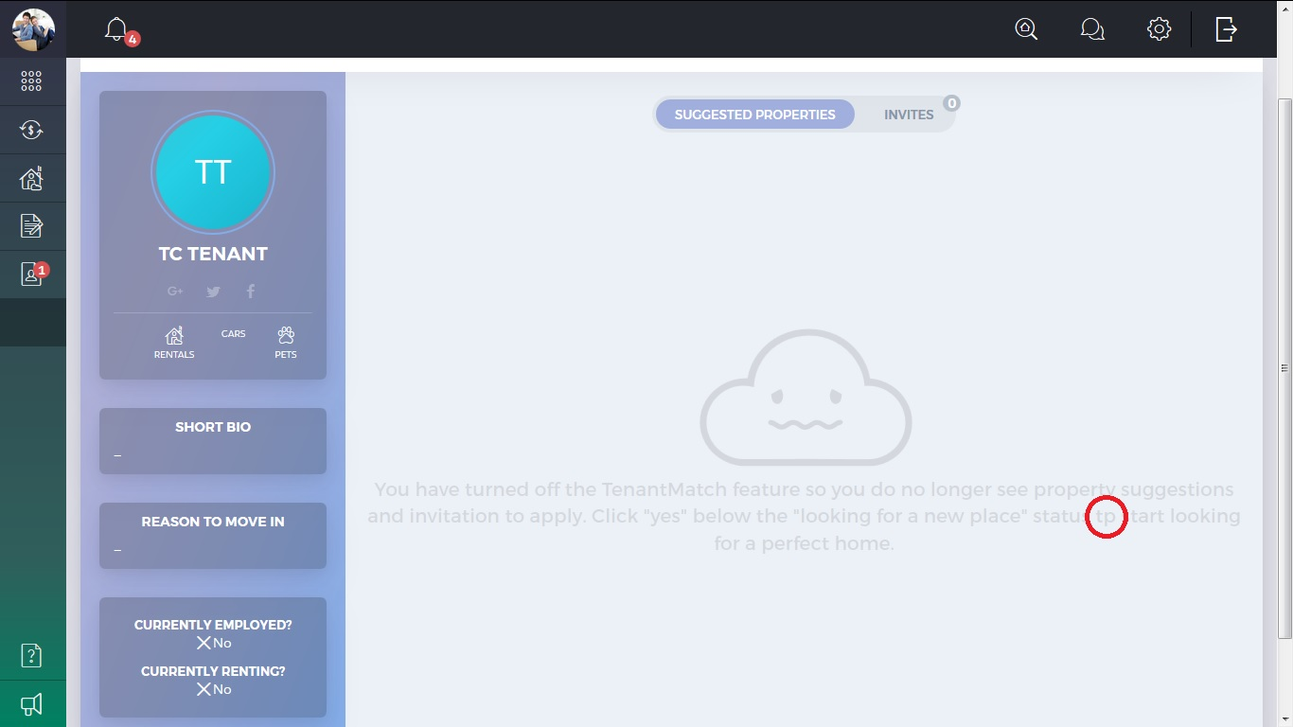

7. 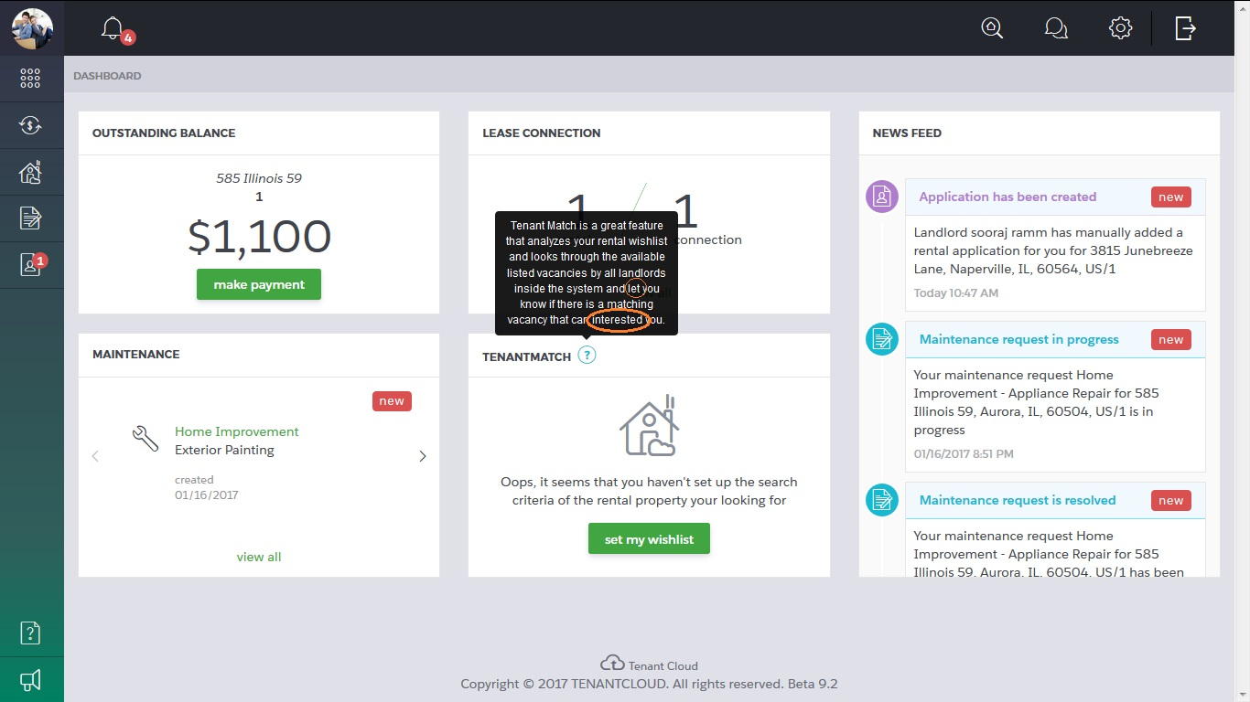

Lets and interest respectively.

8. 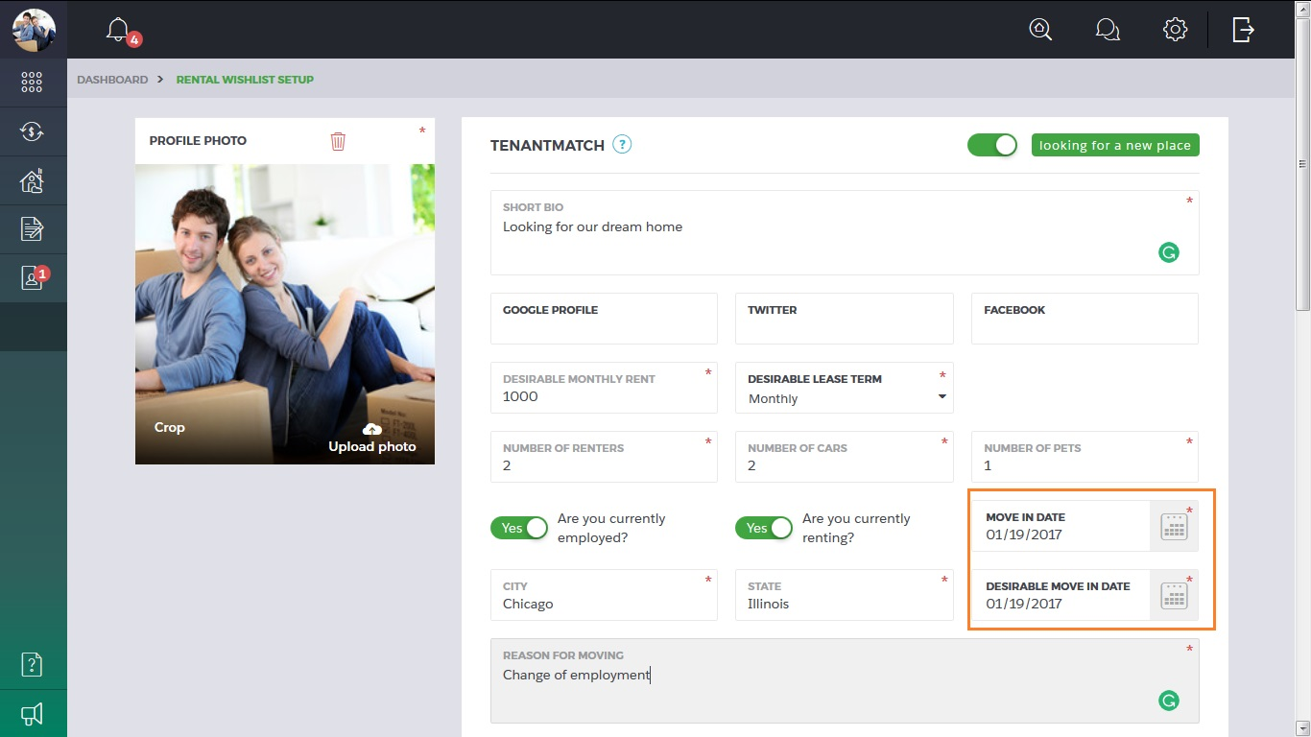  
Looks like a duplicate field. Question ----clarify-----

10. 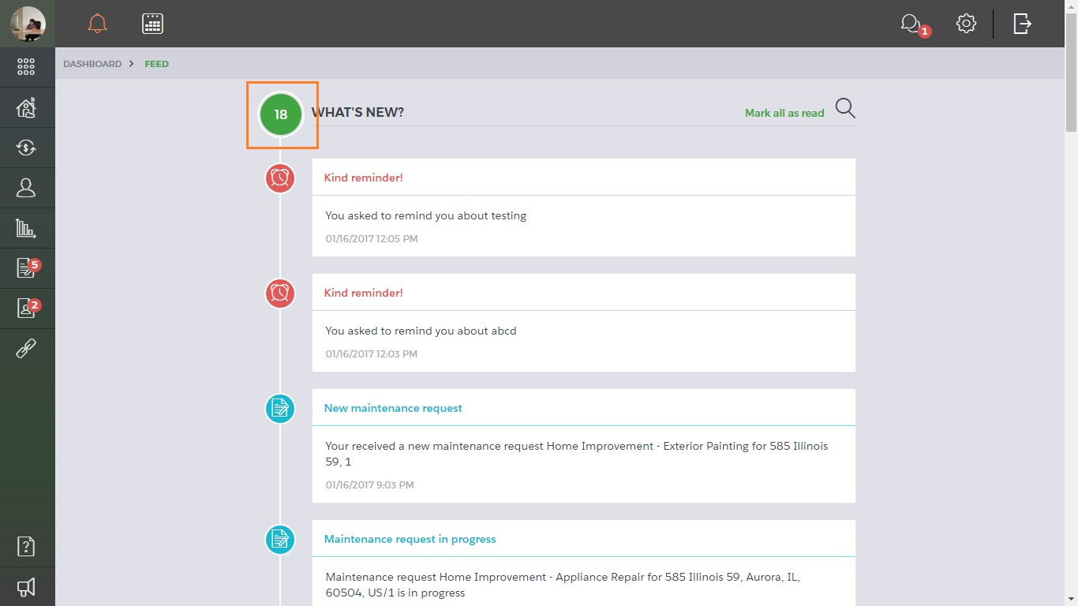  
What does this number signify? -----clarify-----

11.

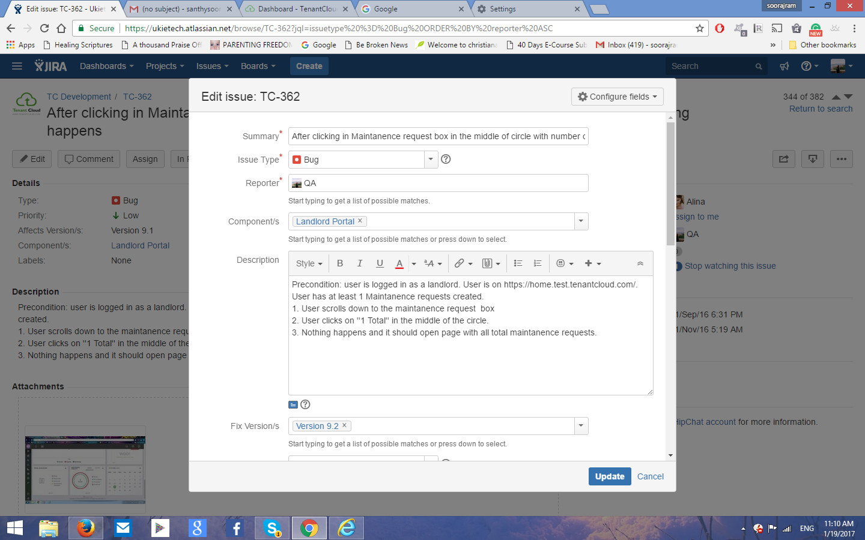

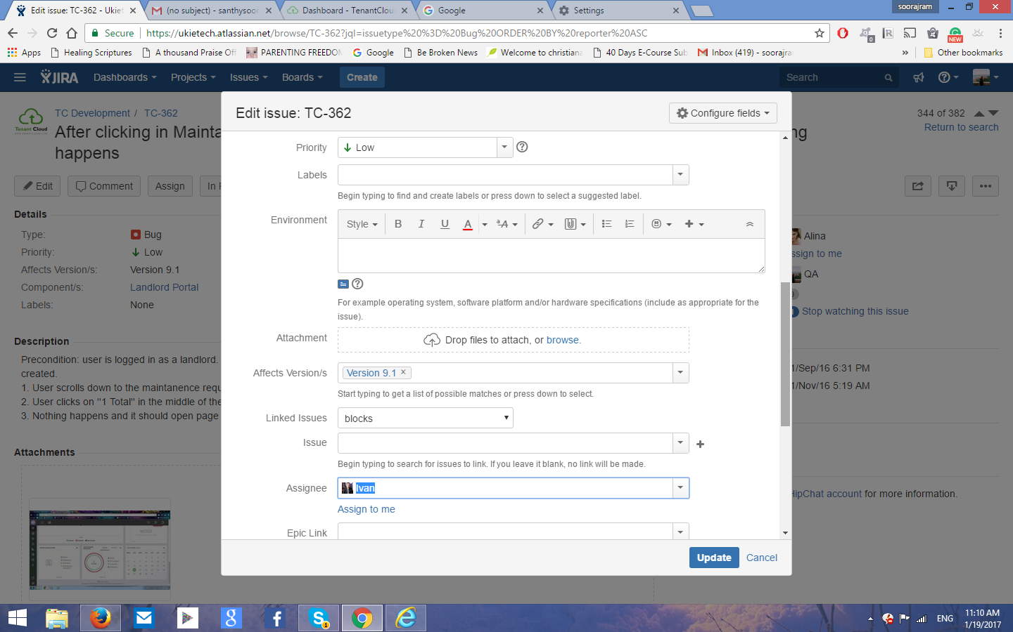

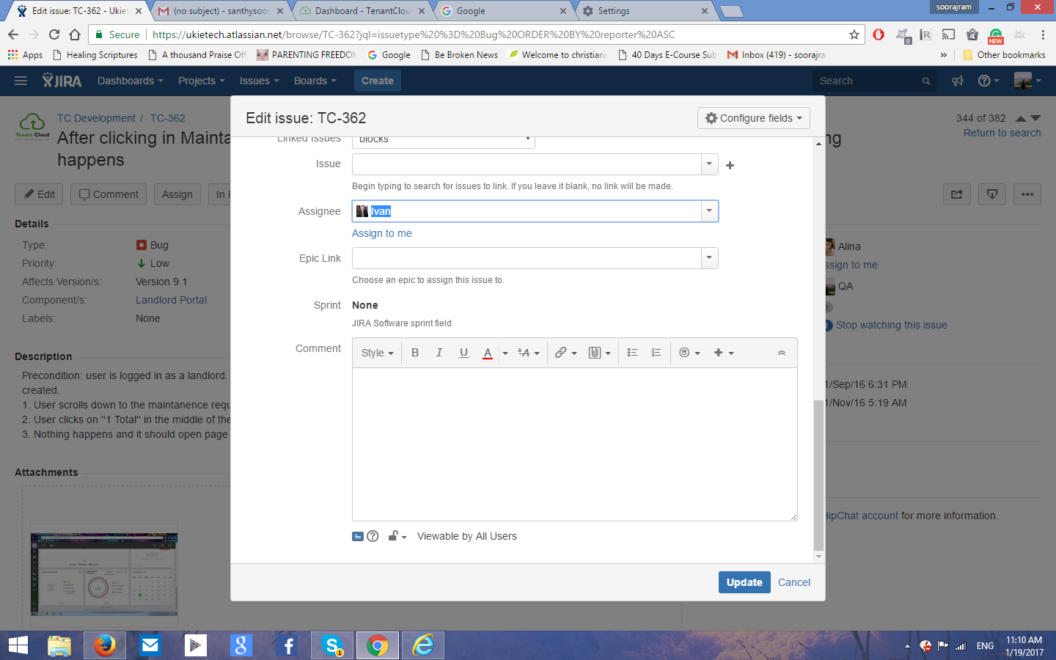

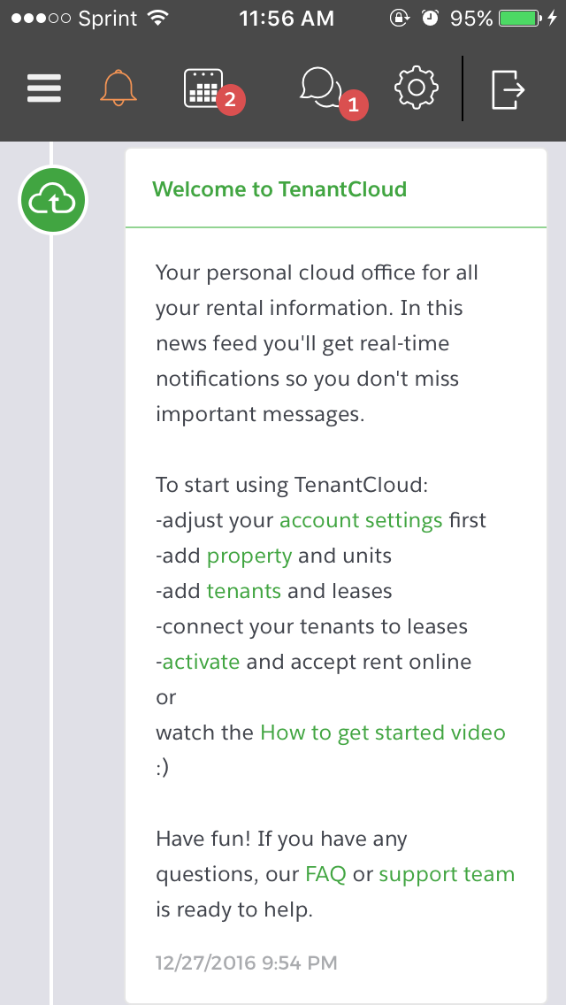

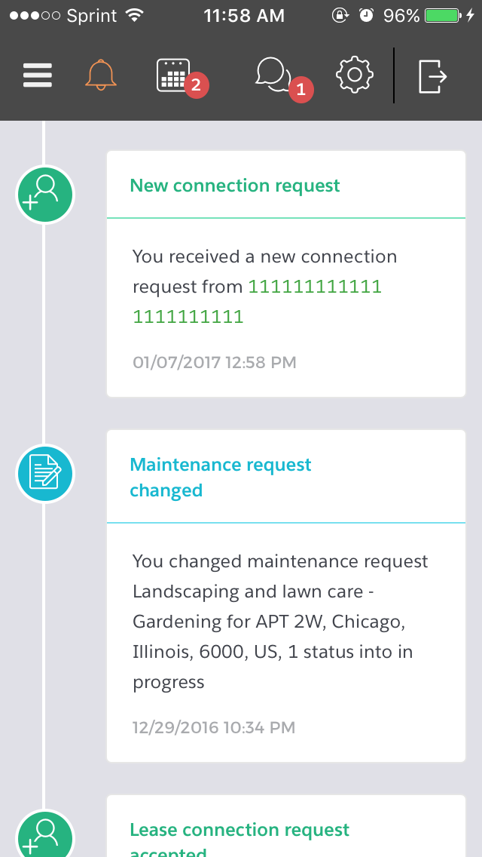

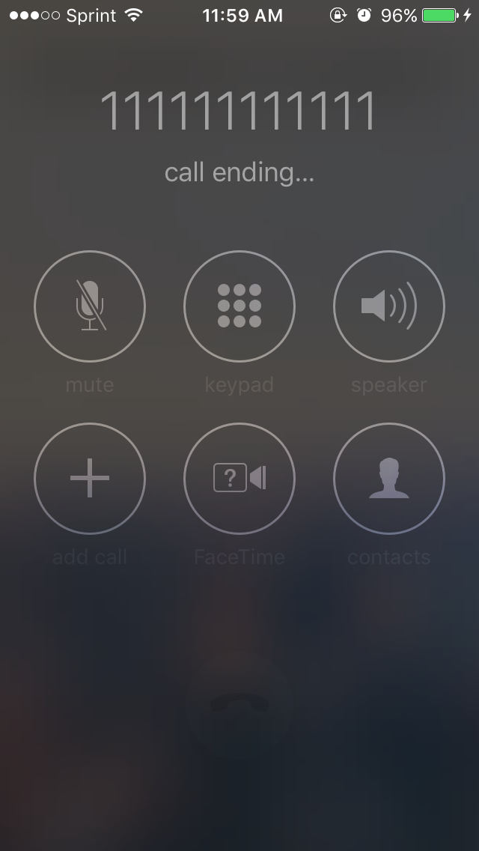

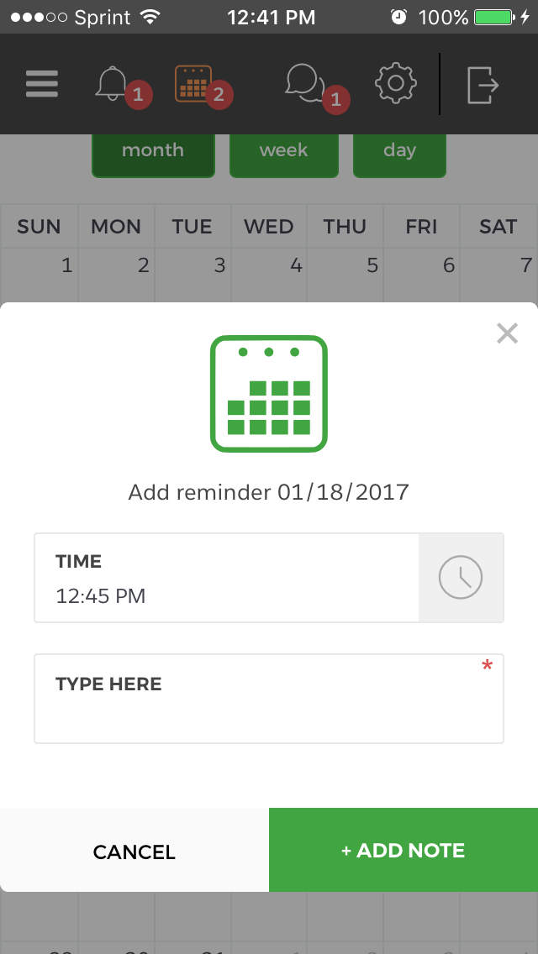

14. 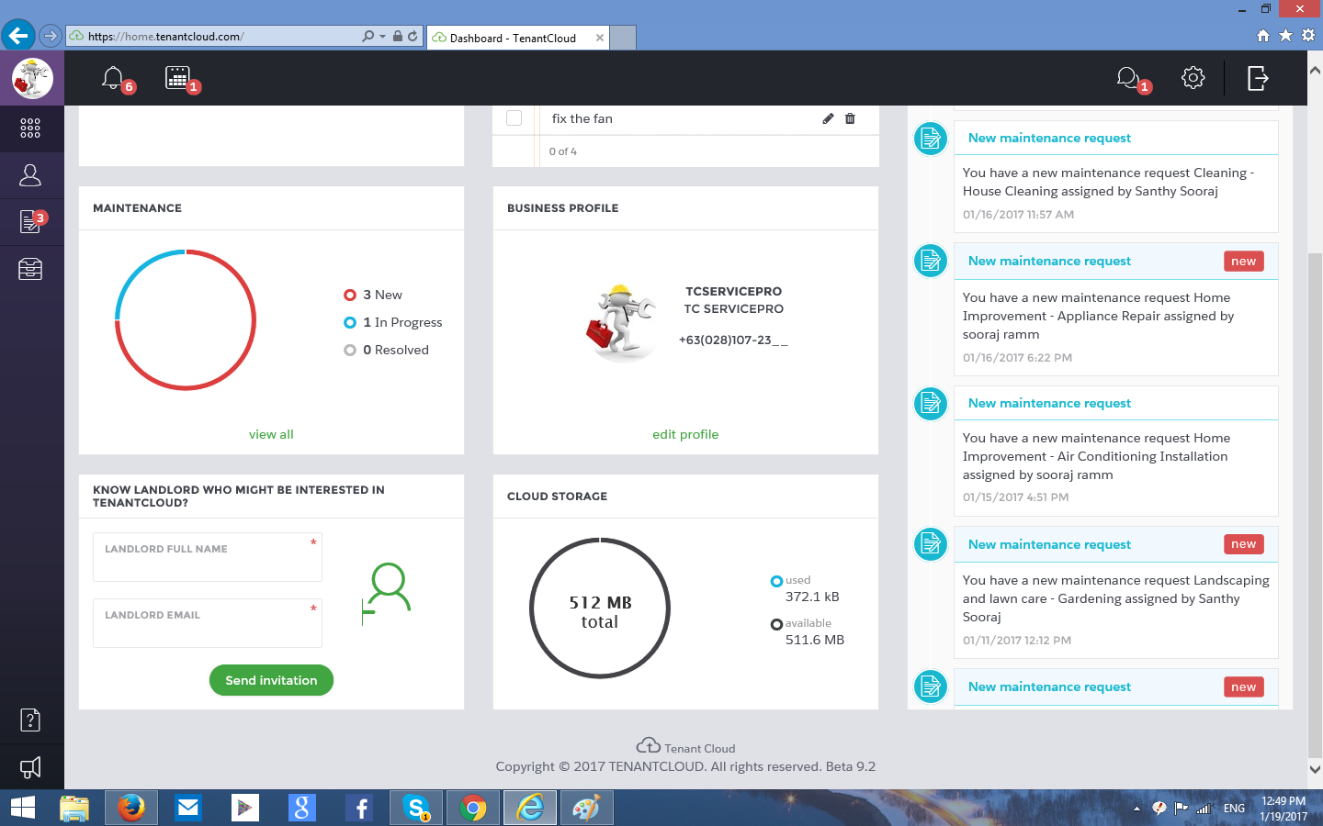

Why is the landlord name a required field? The name isn’t used by the system anywhere, even in the email sent to the landlord.

15.

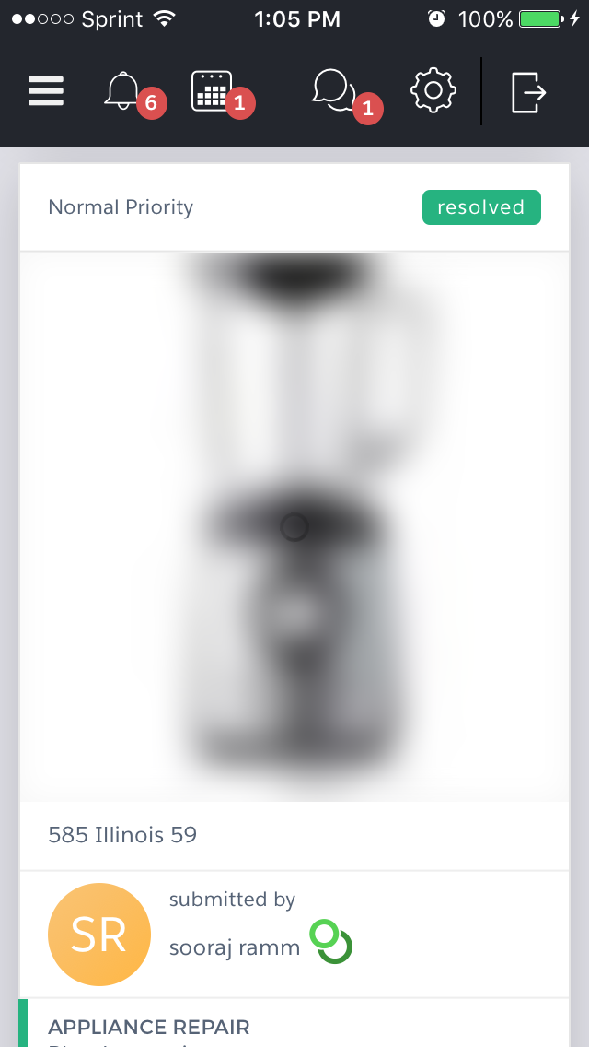

Picture not clear on ServicePro maintenance requests.

17. 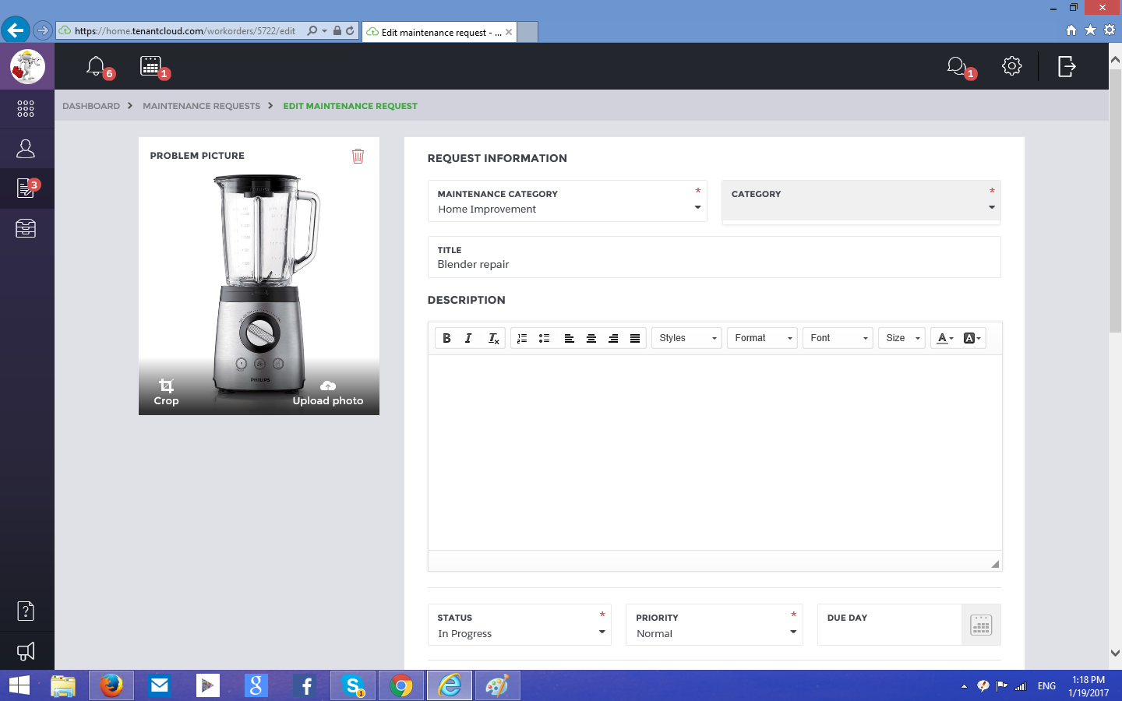  
Category drop down list isn’t working.

18.

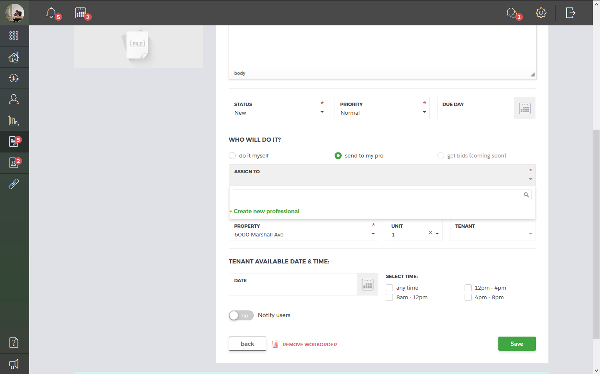  
Send to my pro isn’t showing the ServicePro names.

21. 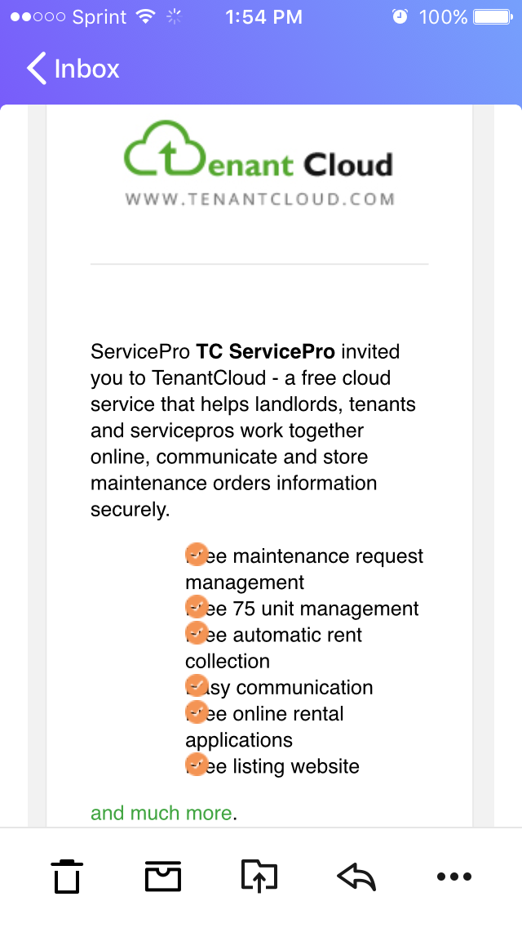

Suggestion.

23. 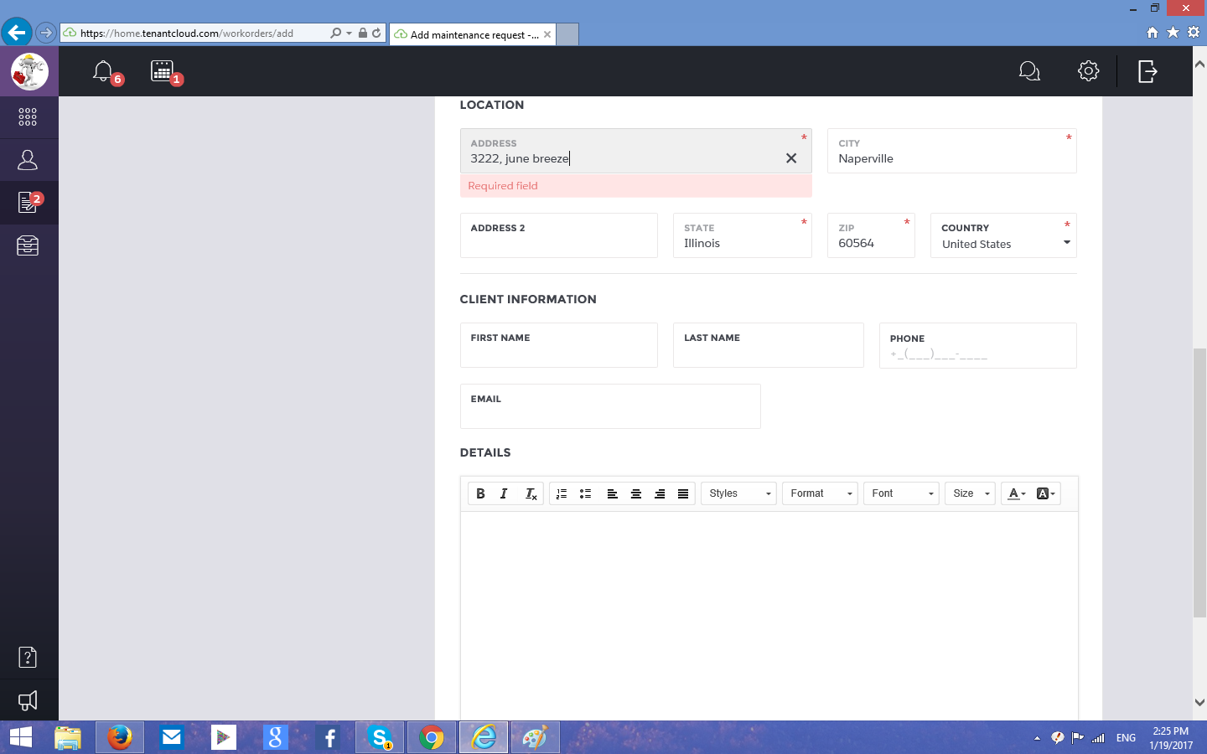

Add maintenance request in ServicePro. Address field not accepting. (Suggestion)

------------------------------------------------------------------------------------------------------------

1. “Category” is written instead of subcategory at the top right corner dropdown list

2.

Just a suggestion. Isn’t “wrong email address” a better usage..

.

3. Difference between the system clock and the chat time.

4.  
I don’t see a place to input the main income. suggestion

5.  
Clarifying again.???Deleted user’s messages showing up in the message icon but not below.

6.

We are editing the rental application from the tenant side and changing the email address of the landlord. Wouldn’t the connection request also be send to the new landlord? It isn’t sending a connection request to the newly edited landlord.

Trying to resend from rental information screen (you can even see the new email id above the resend button) brings up the following error.

(1. Should try to resend the request from tenant and see if it is working.

2. Should see if landlord is making a new property automatically from the request. Fail

3. Should switch to servicepro and try if the resend feature is working there. Pass.

4. What happens if the tenant deletes the lease request before the landlord accepts it.

5. Should check if any tenant is able to connect to the landlord (normal scenario)

6. Change the name of landlord in the application from tenant side and see.

7. Try resending the application from [serviceprotc@yahoo.com](mailto:serviceprotc@yahoo.com) after the timer. Failed

___________

1. Paypal Ukraine specific
2. 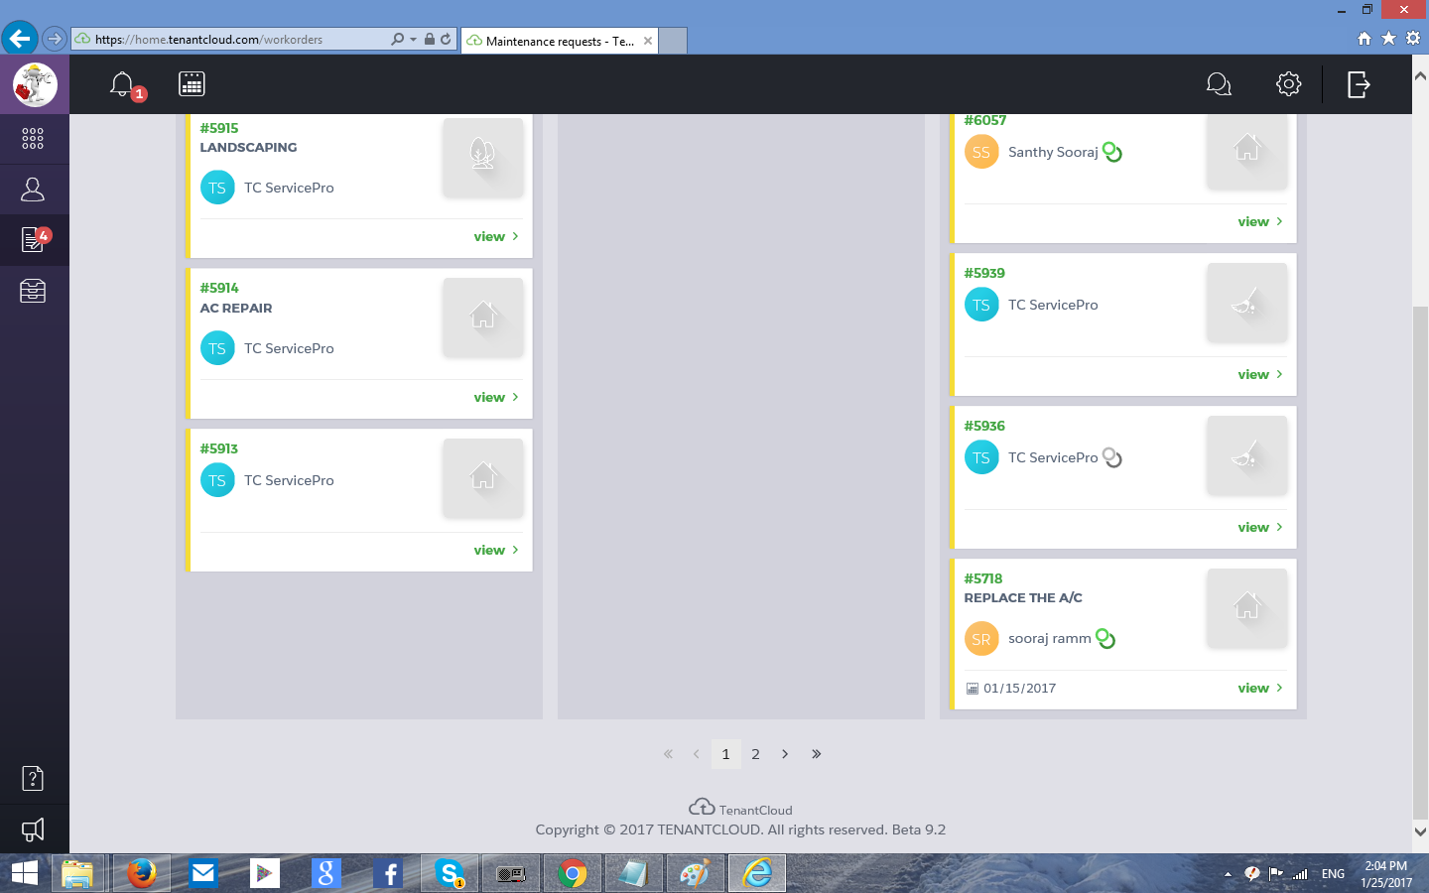  
   Don’t know what are the 1, 2 > >> is

3. 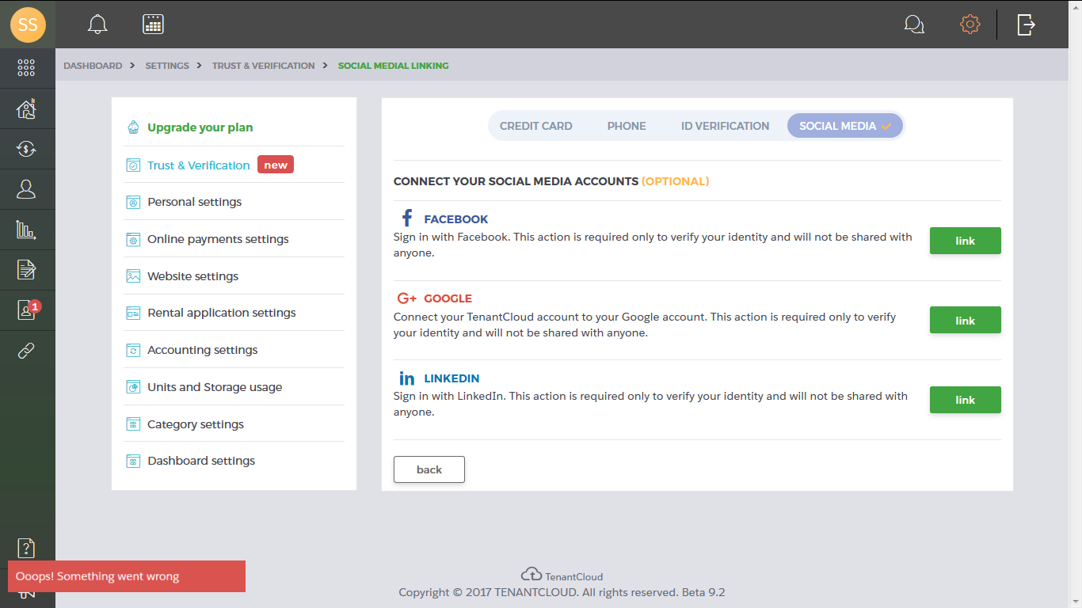  
When we close the window to login to google+, this error message is displayed.

ahoo.com